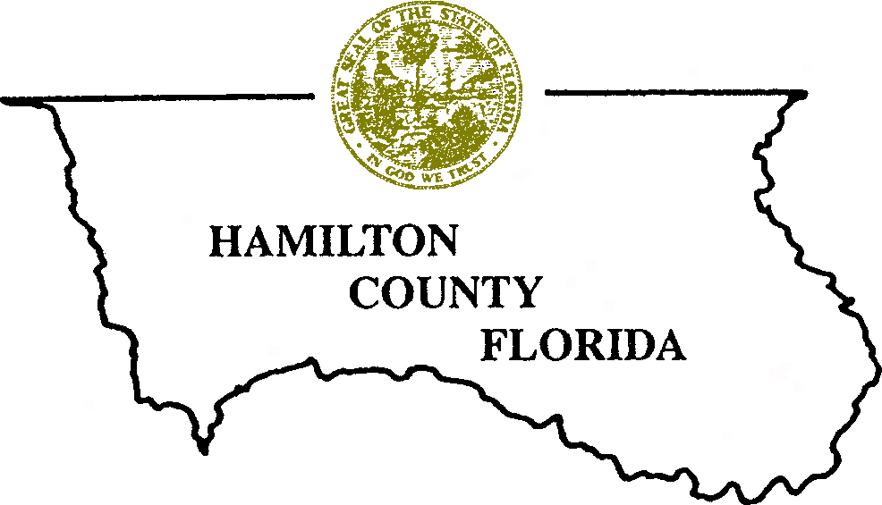
JIMMY MURPHY GREG GODWIN
District 1 - Jennings Clerk of Courts
ROBBY ROBERSON ANDY DECKER
District 2 - Jasper County Attorney
JAMES HOWELL
District 3 - Jasper
TRAVIS ERIXTON 204 Northeast First Street
District 4 - White Springs Suite B, Sandlin Building
RICHIE MCCOY Jasper, Florida 32052
District 5 - Jasper O: (386) 792-0507
F: (386) 792-3080

LAND USE DEPARTMENT
Zoning and/or Land Use Verification Form
Fee: $25.00 (All Application Fees are Non-Refundable) If you have any questions, please contact the Land Use Department at 386-792-0507. Applications can be mailed to the Hamilton County Land Use Department, 204 NE First Street, Suite B, Jasper, Florida 32052.
Date:

Contact Information
Name:

Mailing Address:

City State Zip

Phone: Fax:

Email:

Parcel Information
Parcel Identification Number:

Parcel Street Address:

Requesting Zoning Verification: ☐yes ☐no Requesting Land Use Verification: ☐yes ☐no

(Below to be completed by Land Use Department staff ONLY)

Zoning District:

Land Use District:

Land Use Department Signature Date Issued
Please note that any allowable use must comply with any and all applicable Codes, Ordinances, or Regulations. If you have any questions, please contact the Land Use Department at 386-792-0507. Applications can be mailed to the Hamilton County Land Use Department, 204 NE First Street, Suite B, Jasper, Florida 32052.

This certificate is exclusive of the terms and conditions herein and is valid under the Hamilton County Comprehensive Plan (Comp Plan) and the Hamilton County Land Development Regulations (LDR) in effect at the date of issuance. Amendments to the Comp Plan or to the LDR may alter the terms and conditions of this verification.

